4CH 4G WiFi SD card Mobile DVR
Model:OX-MD214

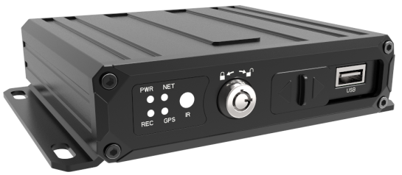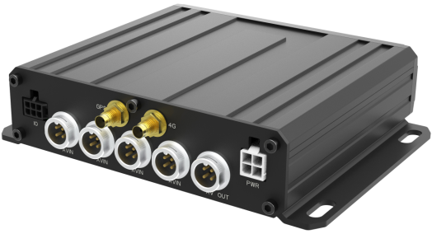

Product features
This series of products is a Super cost-effective 4G WiFi SD Card Mobile DVR designed for the mobile surveillance market. Support wide power Voltage input, support large-capacity SD card recording, USB backup; use professional and reliable aviation plug connectors; unique UPS technology, combined with advanced software and hardware, and incorporate a series of detailed considerations to make the product more outstanding; High appearance, Precise structure, low power consumption, good heat dissipation; simple installation, easy operation, and extremely stable; widely used in passenger Coach, buses, taxis, school buses, logistics vehicles, dangerous goods vehicles, Sedan cars, ships, etc.

The detailed features are as follows：
- Industrial design, stable and reliable, easy to install
- Video adopts the international mainstream H.265/H.264 encoding format, and the audio adopts G711a encoding. It can support up to 4 channels of 1080P. high compression ratio , clear image, and Use small disk space .
- Professional vehicle power supply, can adapt to 8 to 36V ultra-wide voltage input, with multiple protection circuits such as overload/short circuit/reverse connection
- Highly reliable aviation plug input and output interface, easy to install and plug, and stronger Vandal-proof performance
- Support 4 channels of video and audio input, frame rate and image quality are adjustable
- Support single SD card Max 512G large capacity recording
- The video content has the power-off protection function, and the video will be automatically restored when power recovery
- Support video loss alarm function
- Independent delay Power shutdown , can support the system to continue running after the vehicle is turned off, the delay time can be set by yourself
- Supporting CMS client platform, providing multiple functions such as playback, analysis, management, etc.
- Support Firmware upgrade via SD card or U disk
- Support 1 x RS232, can be connected to RFID card reader, oil sensor, temperature sensor, etc.
- Support 4G , WiFi and GPS function

Main functions
Item | Description | Feature
Video subsystem | Video channel | 4 channels, 1 to 4 video channels are optional, 4 audio channels
Video subsystem | Resolution | Support 4 channels 1080P, 720P, D1, CIF, etc.
Video subsystem | Video quality | Multiple levels are optional
Video subsystem | OSD | Various characters can be superimposed, such as date and time and channel ID, etc.
Video subsystem | Loop recording | Support SD card loop recording and loop coverage
Video subsystem | Video mode | Support boot recording, timing recording, alarm trigger recording
Video subsystem | Preview | Support single screen and multi screen
Playback subsystem | Video search | Supports search at any time within a certain day, and multiple search types are supported
Playback subsystem | Replay | Support multi-channel comparison playback
Playback subsystem | Replay | Support fast forward and fast rewind, respectively supporting 2, 4, 8, 16 times speed optional
Playback subsystem | Replay | Support alarm point search and time point search
GUI | Graphical interface | Support configuration of various parameters through the remote control
other | Power ON/OFF | Support delay power on/off
other | Power ON/OFF | Support ACC power on/off and time power on/off machine

Specifications
Item |  | Parameters
OS |  | Embedded Linux
System language |  | English, other (Can be customized for free)
Video compression format |  | H.265/H.264 compression format
OSD |  | Character superposition function, support time and date, vehicle ID and other information image superposition
GUI | graphic interface | System parameters can be set through external display and remote control operation
Video and recording system | Video input | 4CH video inputs (aviation plug interface), 1.0Vp-p, 75Ω
Video and recording system | Video output | 1CH mixed video output (VGA output can be customized), 1.0Vp-p, 75Ω
Video and recording system | Preview function | Single-channel or multi-screen splicing preview, support manual/event trigger full-screen display function
Video and recording system | Video resolution | 4CH machine supports 1080P/720P/D1/CIF optional, and the maximum can support 4 channels 1080P
Video and recording system | Record mode | Default automatic recording, support ACC recording, manual recording, alarm recording, etc.
Audio | Audio input | 4CH，aviation plug
Audio | Audio output | 1CH，aviation plug
Audio | Format | G711a compression format
Alarm input |  | 4CH alarm inputs, with alarm linkage function
Alarm Output |  | 1CH output
RS232 |  | Support 1 x RS232
USB |  | Support 1 x USB interface
Positioning |  | Support built-in GPS/BD(GPS/GLONASS) module
sensor |  | Support built-in acceleration sensor
Network | 4G | Support built-in 4G function
Network | WiFi | Support built-in WiFi function
Video storage | SD Card | Maximum support 1x512G SD card, loop recording
Video storage | File format | H.265/H.264
Video playback | Video search | Search for recording video files by recording time, recording mode, etc.
Video playback | Playback | Support multi-channel synchronous playback, support fast forward and fast reverse, support 2, 4, 8, 16 times speed optional
upgrade | Firmware upgrade | Support SD Card Upgrade, Support Network upgrade
Power | Power management | Adaptive wide power Voltage input, with protection functions such as overload, overvoltage, undervoltage, short circuit, and reverse connection;Support timing power on/off , delayed power on/off function
Power | Input voltage | DC:8 ~ 36V
Power | Consumption | Normal work maximum：5W，standby：0.5W
working environment | temperature | -20℃ to +70℃
working environment | humidity | 20% to 80%
Safety management | Password access | Two-level management of user password and administrator password
Other | Size： | 153(W) x35(H) x121(L) mm
***** If the above parameters are changed, please refer to the actual product *****

4G Model | Country | 4G Frequency band
1 | China, Thailand, Indonesia, India, Vietnam, the Philippines, Saudi Arabia, Bonaire Island, Aruba, curacao, Azerbaijan, Bhutan, Brunei, Cambodia, Hong Kong, Kazakhstan, Pakistan, the Philippines, Sri Lanka, Israel, Egypt | GSM:900/1800  WCDMA:B1/B8  FDD_LTE:B1/B3/B5/B8  TDD_LTE:B38/B39/B40/B41  TD-SCDMA:B34/B39  EVDO/CDMA:BC0
2 | Malaysia, Singapore, Taiwan, britain, Russia, Djibouti, Somalia, Morocco, South Africa, the republic of korea, Uzbekistan, Mozambique | GSM:900/1800  WCDMA:B1/B8  FDD_LTE:B1/B3/B7/B8/B20/B28  TDD_LTE:B38/B40/B41
3 | Chile, El Salvador, Mexico, Peru | LTE-FDD:B2/B4/B5/B7/B8/B28  LTE-TDD:B40  WCDMA:B2/B5/B8  GSM:850/900/1800/1900
4 | U.S.A | LTE-FDD:B2/B4/B5/B12/B13/B17/B25/B26  LTE-TDD:B41  WCDMA:B2/B4/B5  CDMA&EVDO:BC0/BC1  GSM:850/1900
5 | Brazil | FDD LTE:B1/B2/B3/B4/B5/B7/B8/B17/B20/B28  TDD LTE:B34/B38/B39/B40/B41  WCDMA:B1/B2/B5/B8
***** If there is an unsupported frequency band, please contact the manufacturer *****

Front panel

Front panel appearance diagram
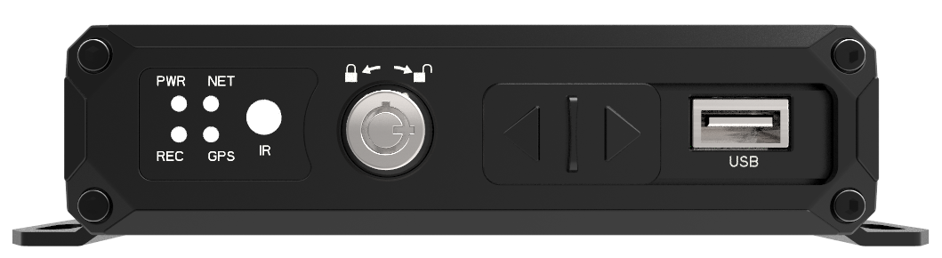

Front panel function introduction
Serial | Name | Silk Print | Detailed description
 | Remote receiver | IR | Infrared receiver, used to receive remote control signal
② | Indicator LED | PWR | Power Indicator LED. LED ON when the power supply is normal
② | Indicator LED | REC | Video indicator LED. Flashes when recording
② | Indicator LED | NET | Network status indicator. The light will always be on when the network connection is successful, and flash when the network is not connected
② | Indicator LED | GPS | GPS status indicator. The light is always on when the GPS is working normally, and it flashes when there is no signal
③ | Electronic locks | LOCK | When the electronic lock is locked, MDVR automatically turns on; when the electronic lock is opened, MDVR automatically turns off
④ | USB port | USB | Use to backup files and upgrade firmware version
⑤ | SD card port  SIM card port | SD/SIM | Open the interface baffle through electronic lock, insert SD card and SIM card. When the electronic lock is locked, please do not open the interface baffle forcefully, it will damage the machine

Back Panel

Appearance of the Back panel:
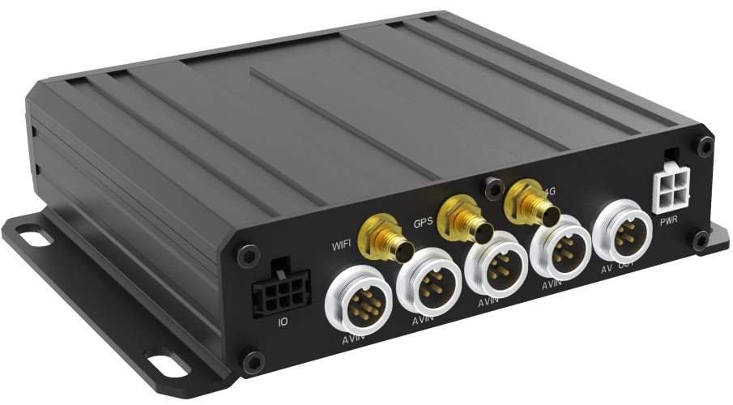
Serial | Name | Silk Print | Description
① | AV input Port | AV1 | 1CH audio and video input interface
① | AV input Port | AV2 | 2CH audio and video input interface
① | AV input Port | AV3 | 3CH audio and video input interface
① | AV input Port | AV4 | 4CH audio and video input interface
② | AV output Port | AV OUT | Standard CVBS audio and video output interface (can be changed to VGA interface)  1 x RS232
③ | Power Port | PWR | Power Input port
④ | I/O Port | I/O | 4CH Alarm input, 1CH Output
⑤ | GPS Antenna Port | GPS | External Special GPS antenna. It should be placed where without shielding and interference
⑥ | 4G Antenna Port | 4G | External Special 4G antenna. It should be placed where without shielding and interference
⑦ | WiFi Antenna Port | WiFi | External Special WiFi antenna. It should be placed where without shielding and interference

Power interface definition
Pin definition | Serial | definition
 | 1 | GND
 | 2 | Power +
 | 3 | ACC
 | 4 | NC

I/O interface definition
Pin diagram | Pin definition
 | 1 | 2 | 3
 | GRAY | GRAY | YELLOW
 | Alarm input 1 | Alarm input 3 | Alarm output
 | 4 | 5 | 6
 | GRAY | GRAY | BLACK
 | Alarm input 2 | Alarm input 4 | GND

Aviation plug interface definition
There are a total of 5PCS aviation Plug Port on this machine, 4CH audio and video input interfaces are 4pcs x 4pin aviation port, and 1pcs x 7pin AV output：

The detailed definition of the video input aviation head is as follows:
4pin aviation port pin definition
pin | definition
1 | +12V
2 | GND
3 | Audio Signal
4 | Video Signal

The detailed definition of AV output aviation head is as follows:
7pin aviation port pin definition
pin | definition
1 | RS232 RX
2 | Audio Output
3 | CVBS Output
4 | RS232 TX
5 | +5V
6 | +12V
7 | GND

OUXIANG INTERNATIONAL LIMITED www.oxiang.com.cn 0086-755-27043175

